Nepal College of Information Technology
Unit Test
Spring 2012
Program : BE CE Time : 2 hrs
Semester : (IV) FM : 60
Subject : Theory of Computation PM : 30

- Candidates are requested to give their answer as far as practicable in their own words.
- The figure in the margin indicates the full marks
- Attempt ALL question

1 a) Define Finite state automata. Convert the following NFA to DFA. [7]
Q \Σ | a | b
->q ₀ | {q₀, q₁} | {q₂}
q ₁ | {q₀} | {q₁}
*q ₂ | φ | {q₀, q₁}

b) What do you mean by epsilon NFA? Construct a NFA without epsilon transitions from the following epsilon NFA. [10]
Q \Σ | a | b | c | ∈
->q ₀ | {q₀ } | {φ} | {φ} | {q₁}
q ₁ | {φ} | {q₂} | {φ} | {q₂}
*q ₂ | {φ} | {φ} | {q₂} | {φ}

2 a) Construct Finite Automata (FA) for the following regular expressions: [10]
i) (10*1 + 01*0)
ii) (a+b)*(aa+bb)(a+b)*
b) Find the Regular Expression for the following NFA: [8]

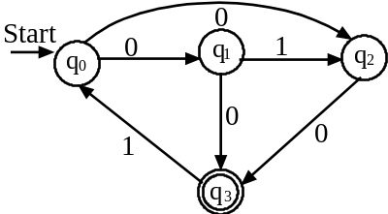
3 a) State the closure property of regular sets. Show that the class of regular language is closed under concatenation. [7]
b) State and prove pumping lemma for regular sets. [8]
4 Write short notes on (any two). [2*5 =10]
a) Regular expression
b) Derivation tree with example.
c) Grammar.

